# Exercises: Inheritance

Problems for exercise and homework for the [Python OOP Course @SoftUni](https://softuni.bg/courses/python-oop).

Submit your solutions in the SoftUni judge system at <https://judge.softuni.bg/Contests/1941>.

## Person

You are asked to model an application for storing data about people. You should be able to have a Person and a Child. Every person receives **name** and **age** upon initialization. Your task is to model the application.

Create a **Child** class that inherits **Person** and has the same constructor definition. However, do not copy the code from the **Person** class - **reuse the Person class's constructor**.

Submit in judge a **zip file** named **project**, containing a separate file (person.py and child.py) for each of the classes.

|  |  |
| --- | --- |
| **Test Code** | **Output** |
| person = Person("Peter", 25)  child = Child("Peter Junior", 5)  print(person.name)  print(person.age)  print(child.__class__.__bases__[0].__name__) | Peter  25  Person |

## Zoo

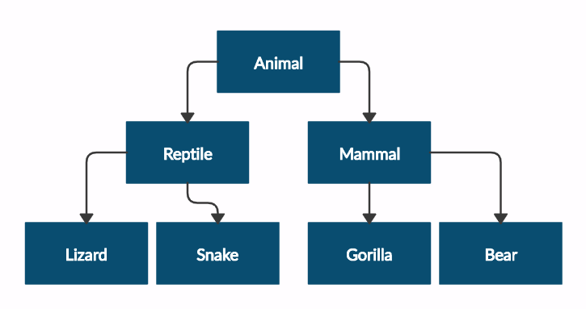Create a zoo project that contains the following classes:

Submit in judge a **zip file** of the **project**, containing a separate file for each of the classes using the structure shown below:

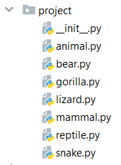

Follow the diagram and create all the classes. **Except for the Animal class, each class** should **inherit** from **another** **class,** as shown in the diagram. The **Animal** class should receive a name - string upon initialization.

Every class should have a constructor, which accepts one parameter: **name**

|  |  |
| --- | --- |
| **Test Code** | **Output** |
| mammal = Mammal("Stella")  print(mammal.__class__.__bases__[0].__name__)  print(mammal.name)  lizard = Lizard("John")  print(lizard.__class__.__bases__[0].__name__)  print(lizard.name) | Animal  Stella  Reptile  John |

## Players and Monsters

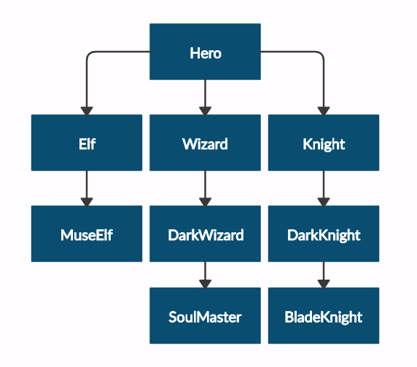Your task is to create the following game hierarchy:

Submit in judge a **zip file** containing a separate file for each of the classes using the structure shown below:

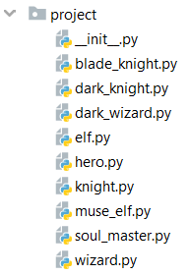

Create a class **Hero**. It should contain the following attributes:

* **username: string**
* **level: int**

Override the **__str__()** method of the base class so it returns: **"{name} of type {class_name} has level {level}"**

|  |  |
| --- | --- |
| **Test Code** | **Output** |
| hero = Hero("H", 4)  print(hero.username)  print(hero.level)  print(str(hero))  elf = Elf("E", 4)  print(str(elf))  print(elf.__class__.__bases__[0].__name__)  print(elf.username)  print(elf.level) | H  4  H of type Hero has level 4  E of type Elf has level 4  Hero  E  4 |

## Need for Speed

Create the following **hierarchy** with the following **classes**:

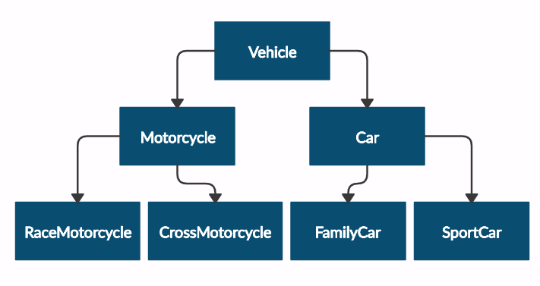

Submit in judge a **zip file** containing a separate file for each of the classes using the structure shown below:

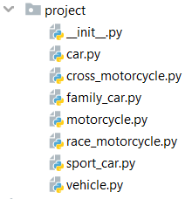

Create a base class Vehicle. It should contain the following attributes:

* **DEFAULT_FUEL_CONSUMPTION: float (constant)**
* **fuel_consumption: float - represents the fuel consumption per kilometer**
* **fuel: float - represents the quantity of fuel in a specific vehicle**
* **horse_power: int**

Upon initialization, the class should receive **fuel** and **horse_power**. The **DEFAULT_FUEL_CONSUMPTION** value should be set to the fuel_consumption value.

Each class should have the following methods:

* **drive(kilometers)** -reduces the **fuel** based on the traveled kilometers and fuel consumption (km * fuel consumption). Keep in mind that you can **start driving** the vehicle only if you have **enough fuel to finish the driving**.

The default fuel consumption for the different vehicles is:

* **Vehicle** is 1.25
* **SportCar** is **10**
* **RaceMotorcycle** is **8**
* **Car** is **3**

|  |  |
| --- | --- |
| **Test Code** | **Output** |
| vehicle = Vehicle(50, 150)  print(Vehicle.DEFAULT_FUEL_CONSUMPTION)  print(FamilyCar.DEFAULT_FUEL_CONSUMPTION)  print(vehicle.fuel)  print(vehicle.horse_power)  print(vehicle.fuel_consumption)  vehicle.drive(100)  print(vehicle.fuel)  family_car = FamilyCar(150, 150)  family_car.drive(50)  print(family_car.fuel)  family_car.drive(50)  print(family_car.fuel)  print(family_car.__class__.__bases__[0].__name__) | e |

## Shop

*Maria is expanding her business, and today, she is opening a grocery shop. You are hired to write a program that keeps track of the shop's inventory.*

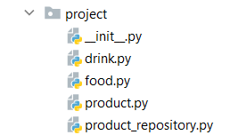

In the **product.py** file, the class **Product** should be implemented. It is a **base class** for any type of food and drink.

The class should receive **name: str**, and **quantity: int** upon **initialization**.It should also have 3 additional methods:

* **decrease(quantity: int)** - decreases the quantity of the product only if there is enough
* **increase(quantity: int)** - increases the quantity of the product
* __repr__() - override the method, so it returns the name of the product

In the file **drink.py**, the class **Drink** should be implemented. The class should **inherit** from the **Product** class. An instance of the **Drink** class will have a **name** and a **quantity** of **10**.

In the **food.py** file, the **Food** class should be implemented. The class should **inherit** from the **Product** class. An instance of the **Food** class will have a **name** and a **quantity** of **15**.

In the **product_repository.py** file, the class **ProductRepository** should be implemented. It is a **repository** for all **products** that are delivered to the grocery shop.

The class should have **products:** **list** - an **empty** list, which will be containing **all products** (objects). Also, the class should have **4 additional methods**:

* add(product: Product) - adds a product to the repository
* find(product_name: str) - returns a product (object) with that name
* remove(product_name) - removes a product from the repository
* __repr__() - override the method, so it returns information for all products in the repository:

"{product_name1}: {quantity1}"

{product_name2}: {quantity2}

…

{product_nameN}: {quantityN}"

|  |  |
| --- | --- |
| **Test Code** | **Output** |
| food = Food("apple")  drink = Drink("water")  repo = ProductRepository()  repo.add(food)  repo.add(drink) print(repo.products)  print(repo.find("water"))  repo.find("apple").decrease(5)  print(repo) | [apple, water]  water  apple: 10  water: 10 |